**National University of Computer and Emerging Sciences**



|  |  |  |
| --- | --- | --- |
|  | **OOAD** | |
|  | **Lab Manual 10** | |
|  |  |  |
| Course Instructor |  | Sir Amir Raheem |
|  |  |  |
| Lab Instructor(s) |  | Asad Ullah |
|  |  | Farwa Batool |
|  |  |  |
| Section |  | B |
|  |  |  |
| Date |  | 20/11/2018 |
|  |  |  |
| Semester |  | Fall 2018 |
|  |  |  |

Department of Computer Science

FAST-NU, Lahore, Pakistan

Keep the following good programming practices in mind when writing your code:

* Comment your code intelligently.
* Indent your code properly.
* Use meaningful variable names.
* Use meaningful prompt lines/labels for input/output.
* use meaningful project and JAVA file name
* create separate java classes for each task

**Task1:**

Please get your lab 9 tasks evaluated.

**Task 2:**

Singelton Pattern involves a single class which is responsible to create an object while making sure that only single object gets created. This class provides a way to access its only object which can be accessed directly without need to instantiate the object of the class.

Use the Singleton pattern when:

1. There must be exactly one instance of a class, and it must be accessible to clients from a well-known access point
2. When the sole instance should be extensible by subclassing, and clients should be able to use an extended instance without modifying their code.

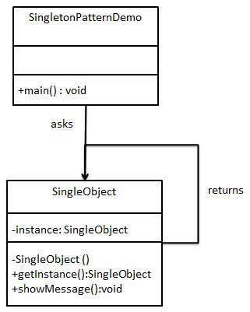

Please run the sample code for the implementation of SINGELTON PATTERN provided with the lab.

**Task 3: (**

(The uml diagram in this question is to introduce some common terms, "dictionary" for online

shopping - Customer, Web User, Account, Shopping Cart, Product, Order, Payment, etc. and

relationships between. It could be used as a common ground between business analysts and

software developers.

Each customer has unique id and is linked to exactly one account. Account owns shopping cart

and orders. Customer could register as a web user to be able to buy items online. Customer is not

required to be a web user because purchases could also be made by phone or by ordering from

catalogues. Web user has login name which also serves as unique id. Web user could be in

several states - new, active, temporary blocked, or banned, and be linked to a shopping cart.

Shopping cart belongs to account.

Account owns customer orders. Customer may have no orders. Customer orders are sorted and

unique. Each order could refer to several payments, possibly none. Every payment has unique id

and is related to exactly one account

Consider a reservation system for an inter-city transportation company that operates buses on

different routes. Each route is determined by a source and destination. On each route different

buses run at different timings. There are two categories of buses that differ in services and

consequently fare. Economy buses provide standard transportation facility and their fare is

computed as a product of the route distance and base rate (fare per km). Luxury buses on the

other hand have a higher base rate, considering reduced seating capacity. In addition, luxury

buses provide different options for refreshments as well as extra luggage, the cost of which can

be added to the fare.

Consider a reservation system for an inter-city transportation company that operates buses on

different routes. Each route is determined by a source and destination. On each route different

buses run at different timings. There are two categories of buses that differ in services and

consequently fare. Economy buses provide standard transportation facility and their fare is

computed as a product of the route distance and base rate (fare per km). Luxury buses on the

other hand have a higher base rate, considering reduced seating capacity. In addition, luxury

buses provide different options for refreshments as well as extra luggage, the cost of which can

be added to the fare.

**(Design Pattern: Singleton Pattern)**

You are asked to develop a mobile application for the government of Pakistan.

This application makes easy for any person of Pakistan to register a complaint against any government department of Pakistan. When a citizen launches a complaint against any department he has to mention a complaint detail and department name. Following the successful launching of a complaint a ticket is generated. Prime Minister of Pakistan is the sole authority and when a complaint is launched, he will issue order to respective government departments heads for the resolution of complaints. There can be at most one Prime Minister at any given time. Department will act on PM instructions and will record their response which will include complaint status including a brief statement of whether complaint is resolved or if any corrupt employee was fired through logging mechanism.

Note: Logging and Prime Minister Classes will require you to implement singleton pattern.